Plagiarism, AI, and Academic Integrity
Denver Seminary Writing Center

Plagiarism: Plagiarism is presenting another’s work or one’s own previous work as one's own original academic achievement without proper acknowledgment.

Plagiarizing includes using a source’s words or ideas without citing that source, including crediting a source but using its exact words without using quotation marks or block indentation. It also includes paraphrasing a source so closely that a side-by-side comparison of your paraphrase and the original text would show that “you could not have written what you did without the source at your elbow.” Plagiarism takes many forms, but all are considered to be a form of taking what belongs to someone else. It is “stealing” and, hence, a breach of ethics and academic integrity.
Use of Artificial Intelligence (AI): The Denver Seminary Student Handbook states that plagiarism includes using “text generated through large language model (LLM) artificial intelligence platforms . . . and utilizing it as one’s own work” (p. 44). These tools should only be utilized to proofread original work, not generate original work passed off as one’s own.

Examples of Plagiarism

1. Intentional Plagiarism of Words: this is the absence of quotation marks or block quotation with proper reference to the source, as is the case in the following example where the writer prefaces the above material with a couple of introductory words:
ORIGINAL SOURCE | PLAGIARISM
You plagiarize when, intentionally or not, you use someone else's words or ideas but fail to credit that person. You plagiarize even when you do credit the author but use his or her exact words without so indicating with quotation marks or block indentation. | I believe that one plagiarizes when, intentionally or not, you use someone else's words or ideas but fail to credit that person. You plagiarize even when you do credit the author but use his or her exact words without so indicating with quotation marks or block indentation.²  Comment: While the source is footnoted, this example illustrates intentional plagiarism by the lack of quotation marks and/or block formatting.  ² Wayne C. Booth, Gregory G. Colomb, and Joseph M. Williams, The Craft of Research, 2nd ed. (Chicago: University of Chicago Press, 2003), 201-2.

2. Intentional Plagiarism of Ideas: this is developing an idea that originates with someone else as a part of one's argument, even when a reference is made to the source, as is the case in the following example:
ORIGINAL SOURCE | PLAGIARISM
You also plagiarize when you use words so close to those in your source. that if your work were placed next to the source, it would be obvious that you could not have written what you did without the source at your elbow. | The "elbow rule" is the norm by which you can check yourself against plagiarism. When you place your writing next to the original and the similarities are so great that it is impossible that you could have written it without the use of a source right in front of you.  Comment: The author does not give credit to the source of his or her idea. It is apparent that he or she has "stolen" it from the original source.

3. Intentional Plagiarism of Papers, Abstracts, etc.: this includes the purchase or copying of someone else's paper, abstract, or thesis and submitting it as if it were one's own.

4. Indirect Plagiarism of Words: this is a paraphrastic use of some else's words, even when loosely reworded; a wording of the material that suggests or implies that it is your own, as is the case in the following example:
ORIGINAL SOURCE | Indirect PLAGIARISM
You plagiarize when, intentionally or not, you use someone else's words or ideas but fail to credit that person. You plagiarize even when you do credit the author but use his exact words without so indicating with quotation marks or block indentation. You also plagiarize when you use words so close to those in your source, that if your work were placed next to the source, it would be obvious that you could not have written what you did without the source at your elbow. | Plagiarism may be intentional or unintentional. Plagiarism is the use of the words or ideas of someone else while not giving credit to the author. Plagiarism even takes place when citing an author while taking over his or her exact words without using quotation marks or block indentation. The test of plagiarism is whether it would be obvious that you could not have written what you did without the source if your work is placed next to the source.  Comment: The paragraph is plagiarized because it is a paraphrastic reworking of the original source without a footnote or parenthetical cite.

Both intentional and unintentional plagiarism are equally serious offenses of the community standards. The latter is, at the very least, an expression of poor scholarship. Carelessness in scholarship is poor scholarship and will not permitted at Denver Seminary.

Further information:
- Denver Seminary’s policy on academic integrity (including plagiarism) can be found in Denver Seminary’s Student Handbook.

- Turabian Manual: Kate L. Turabian, A Manual for Writers of Research Papers, Theses, and Dissertations, 9th ed. (2018)
  - Guard against Inadvertent Plagiarism (4.2.4)
  - Quoting Accurately and Avoiding Plagiarism (25.1)

- APA Manual: Publication Manual of the American Psychological Association, 7th ed. (2020)
  - Implications of Plagiarism and Self-Plagiarism (1.17)
  - Plagiarism (8.2)
  - Self-Plagiarism (8.3)

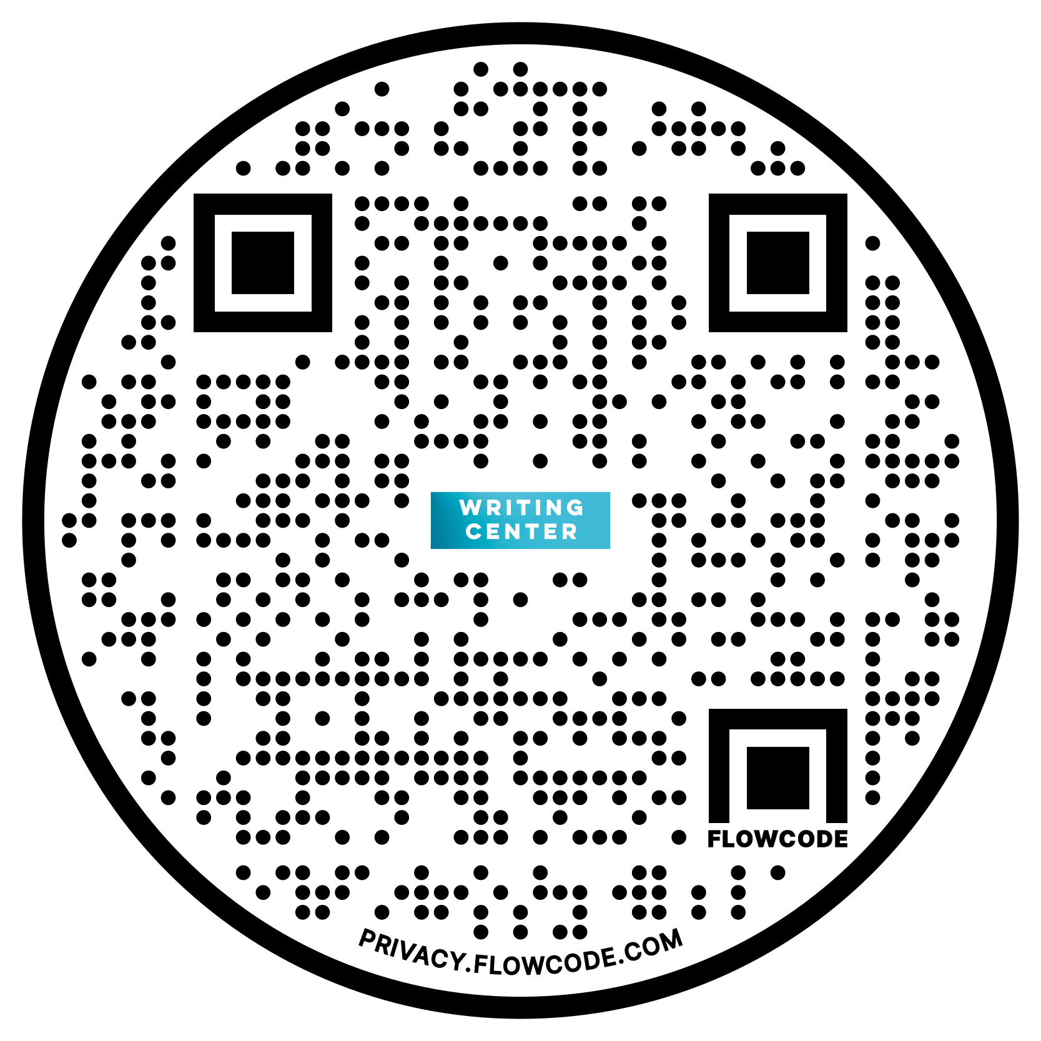

© 2023 – Denver Seminary Writing Center

Wayne C. Booth, Gregory G. Colomb, and Joseph M. Williams, The Craft of Research, 2nd ed. (Chicago: University of Chicago Press, 2003), 201-2.

