Writing and Citing with Academic Integrity

Ten Tips to Improve Your Writing
- Start early!
- Read the assignment in the syllabus carefully and review the rubric if one is provided.
- Locate academic—scholarly, peer-reviewed—sources.
- Take careful notes. Include the bibliographic information with page numbers.
- Spend time away from your research to process ideas.
- Create a basic outline that includes the main points required in your paper. The main points will make logical headings in your paper.
  - The introduction states your thesis and tells your reader why it is important and how you will support your claim. (“Explain what you will tell the reader.”)
  - The body of your paper provides the evidence to support your claim. (“Tell the reader.”)
  - Your conclusion summarizes the evidence and suggests key takeaways. (“Review what you told the reader.”)
- Be clear, concise, and avoid complexity. Avoid jargon and define specialized terms.
- Revise, revise, revise. Take time to refine your arguments.
- Engage with and evaluate your research findings.
- Seek feedback. Constructive criticism can improve your paper.
Avoiding Plagiarism
Plagiarism is using another’s work without documenting the source. Plagiarism applies to other people’s work as well as your own (e.g., lifting portions from a previous paper you have written without citing it). It also includes patchwriting, where the essence of the original work remains.

Why Cite Sources?

- To show readers that you have done your research.
- To give credit to others for the work they have done.
- To provide readers the ability to check your sources if there are questions.
- To point the way for others to build on your work.

Citation Rules
Pro tip: When in doubt, cite it. Give credit where credit is due. To avoid plagiarism, it is always better to err on the side of overciting than to undercite.
Provide a citation whenever:
- Referring to or mentioning a source in general (e.g., a book/article title, entire chapter, whole website, etc.):
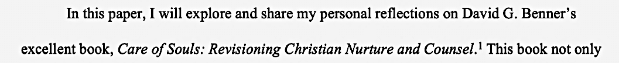

- Quoting from a source (block quote or in text):
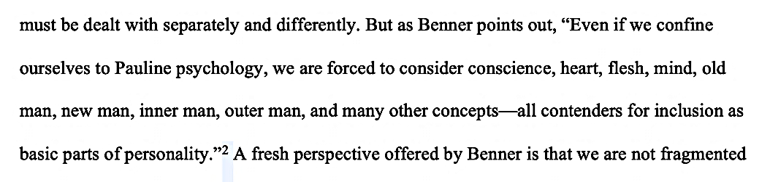

- Paraphrasing or rewording a thought, concept, or idea from a source:

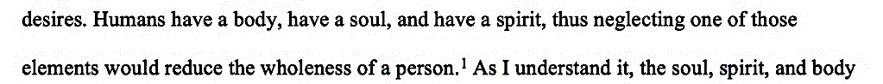

- Referring to your own thought, concept, or idea, or quoting something which you have written in a prior paper. Format such citations as unpublished manuscripts to avoid self-plagiarism.

- Referring to or quoting scripture. To cite scripture in Turabian, refer to this handout and see 17.8.2 in the manual.
Writing Center Resources
Our writing resources are updated and refined often, and new ones are added periodically. We recommend you bookmark our Resources page and refer to our Turabian resources while writing your papers.
We offer information on:
- Writing with gender-inclusive language
- Avoiding plagiarism
- How to use copyrighted material
We also have the following resources, as well as many others, available to download:
Turabian Resources
Turabian formatting checklist | Refer to this list for basic Turabian formatting requirements.
Turabian title page template | Template for the title page with formatting notes.
Turabian examples of common reference types | Examples of footnotes and bibliography entries from common sources.
Turabian sample paper | Example of a title page, one page of text, and bibliography, with formatting notes.
Tips on Turabian PowerPoint | Guidance on citing sources and formatting papers.

Additional resources:
DC campus Writing Center (editing and tutoring): Debora Barr
Free Office 355 for Students
Writing and Citing Webinars

