Formatting Checklist
APA Style

Denver Seminary’s Counseling Division requires the use of the 7th edition of the Publication Manual of the American Psychological Association for writing and formatting papers. This manual is variously referred to as “APA Style” or the “APA manual.” Copies of the APA manual are available on reserve and in the reference collection at the Denver Seminary library. For a complete list of the Writing Center’s downloadable writing resources for APA Style, go to the Writing Center’s Resources page or scan the QR code.

Graduate-level papers must be properly formatted in APA Style. Errors in formatting could lead instructors to misinterpret content or question your expertise or attention to detail. This Formatting Checklist will help you cover the basics. Section numbers from the APA manual are included for further reference.

Checklist Topics:
Paper Components and Formatting
Title Page
Body of Paper
References
Formatting Headings
Heading Levels Table

Paper Components and Formatting (2.16 – 2.25)
Standard graduate-level papers include a title page, the body of the paper, and references. Add page breaks between these components to ensure that each begins on a new page.

Title Page (2.3 – 2.6)
- Follow APA formatting for your title page. Use the “APA Title Page” template found on our Resources page.

Body of paper
- Margins (2.22): Margins should be set to one inch.
- Fonts (2.19): Use an APA-approved font.
      - 11-pt Calibri (used in this document), Arial, or Georgia; 12-pt Times New Roman
    - Line Spacing (2.21): Your entire paper should be double-spaced.
- Block quotations (quotes of 40 words or more) and your paper’s references are also double-spaced.
- Do not add extra lines of space between paragraphs or headings.
- Do not “orphan” single lines of text or headings at the bottom of a page.
  - Page numbers (2.18): Each page, including your title page, should contain the page number in the upper right-hand corner of the header.
  - Paragraphs (2.23 – 2.24)
    - Align the text to the left margin (the right margin should be “jagged”).
    - The first line of each paragraph should be indented 0.5 inches.
    - The entirety of a block quotation is indented .5 inches.
  - Citations (8.10 – 8.22)
      - Parenthetical cites: APA Style uses the author-date system to cite references in the text. Parenthetical citations appear within the body of the paper and identifies the cited work by author and date of publication, e.g., (Alexander, 2022).
      - For examples of parenthetical citations and how and where to insert them, see “Citing References in APA” and “APA Style Presentation” on the Writing Center’s Resources page.
References (2.12; Chapter 9). Most papers require a bibliography, which in APA Style is referred to as a “References” page.
- The references page starts on a new page (insert a page break before).
- “References” is centered and in bold type.
- Each reference cited in the text must have a corresponding entry on the reference list.
- Alphabetize entries by last name.
- Double-space entries (including between and within entries).
- Use a hanging indent: the first line is on the left margin while subsequent lines are indented 0.5 inches. (Use Word to automate this; do not insert hanging indents manually).
  - Use the following format for reference citations: Last, F. M. (Year). Title. Source. If the cite includes a URL, do not place a period at the end of the citation. For examples of reference citations, see “Citing References in APA” on the Writing Center’s Resources page.

For an example of a title page, one page of text, and a reference page, see the “APA Sample” on the Writing Center’s Resources page or the sample student papers at the end of chapter 2 in the APA manual.

Formatting Headings (2.26 – 2.27)
Most papers will require headings. Headings and subsection headings help organize your paper by identifying the topic of each section. All topics of equal importance should have the same level of heading. Avoid having only one subsection heading within a section as a subsection cannot stand alone.

In APA, the first part of a paper is assumed to be an introduction. Therefore, do not begin your paper with an “Introduction” heading. Instead, your paper’s title at the top of the first page of text serves as a de facto Level 1 heading (2.27).

For examples showing the use of headings in context, see the “APA Sample” paper on the Writing Center’s Resources page or the sample student papers at the end of chapter 2 in the APA manual.

Heading Levels Table
The APA manual provides standard formatting for up to five levels of headings:

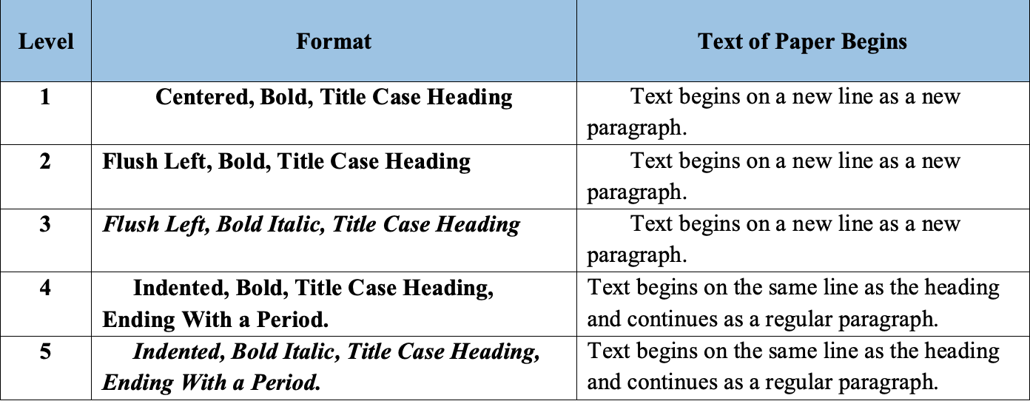
Table 2.3

